Variables specified in the INCLUDE parameter

The selection Window

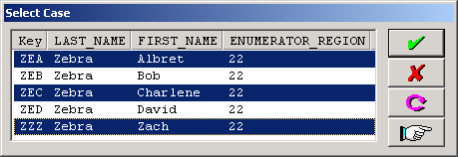

MULTIPLE parameter allows multiple selections